CVNP2646 - Week 2 Assignment
Tamara Arnott
Python Fundamentals: IP Validator, Password Checker, and Python Basics
GitHub Repository: https://github.com/tamara-arnott/CVNP2646-CourseWork
━━━━━━━━━━━━━━━━━━━━━━━━━━━━━━━━━━━━━━━
TASK 1: IP ADDRESS VALIDATOR (ip_validator.py)
01_ip_validator_code.png
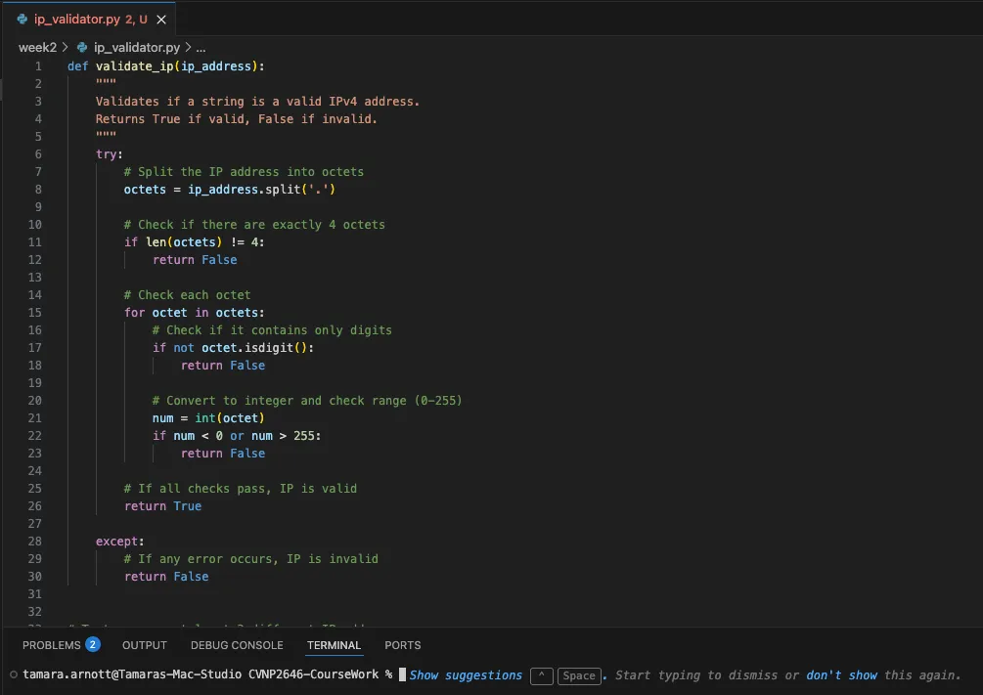

02_ip_validator_output.png
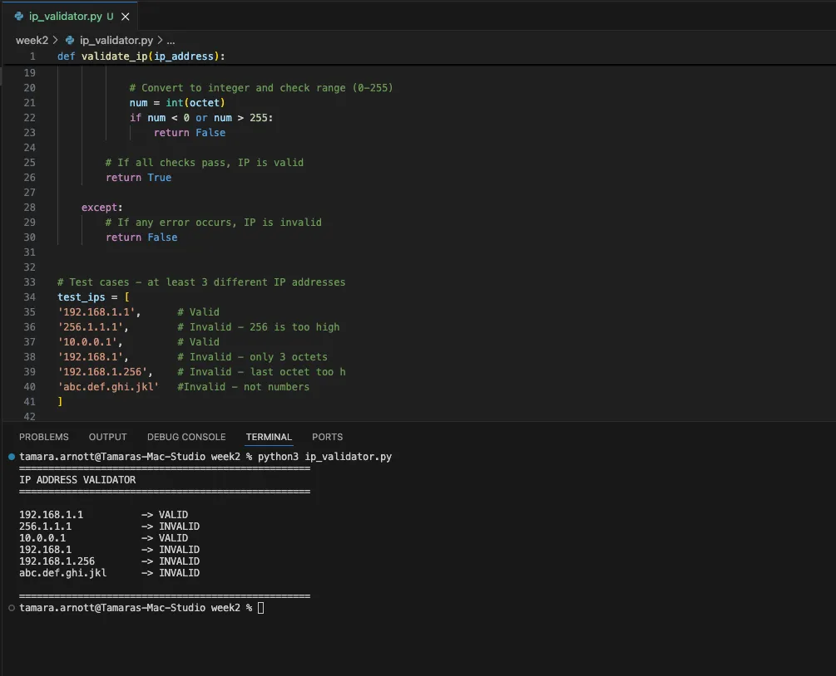

03_ip_validator_github.png
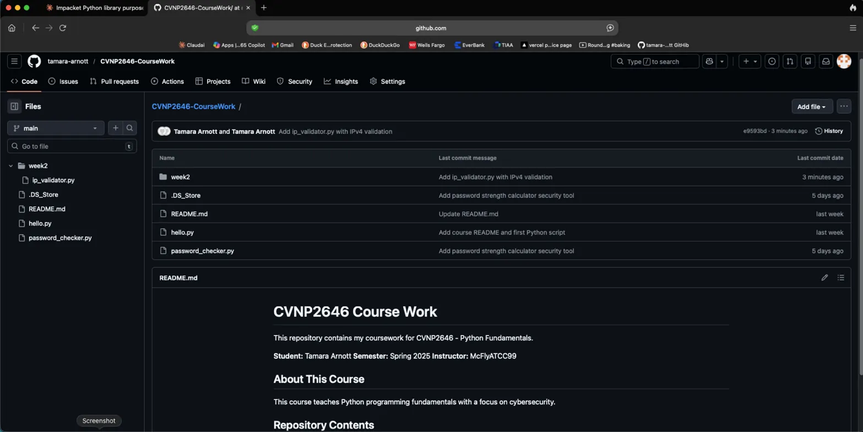
TASK 2: PASSWORD STRENGTH CHECKER (password_checker.py)
04_password_checker_code.png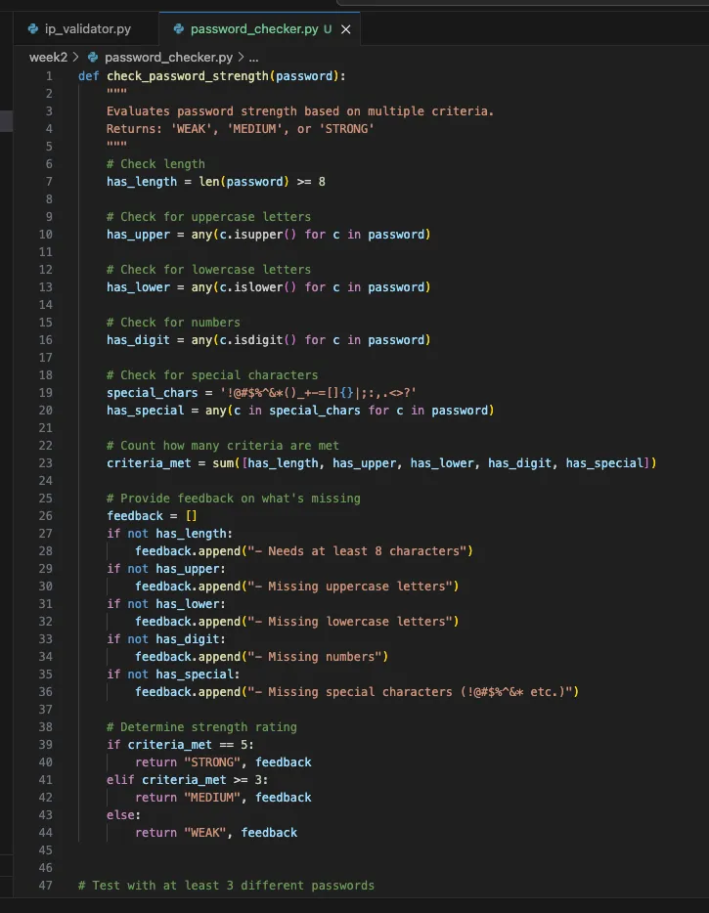
05_password_checker_output.png
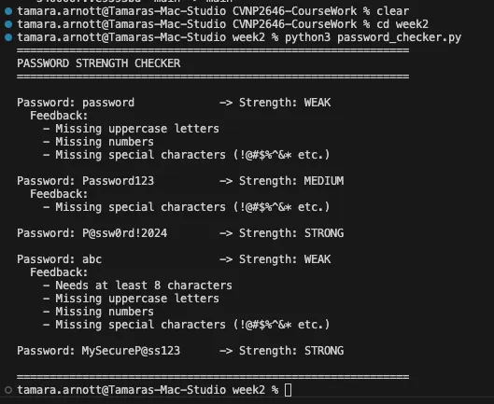
06_password_checker_github.png
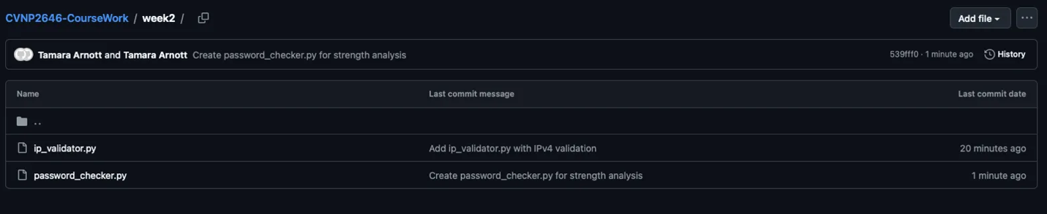

TASK 3: PYTHON BASICS DEMONSTRATION (python_basics.py)
07_python_basics_code.png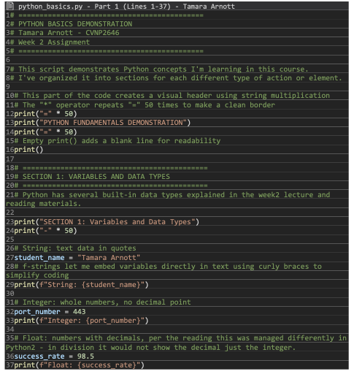
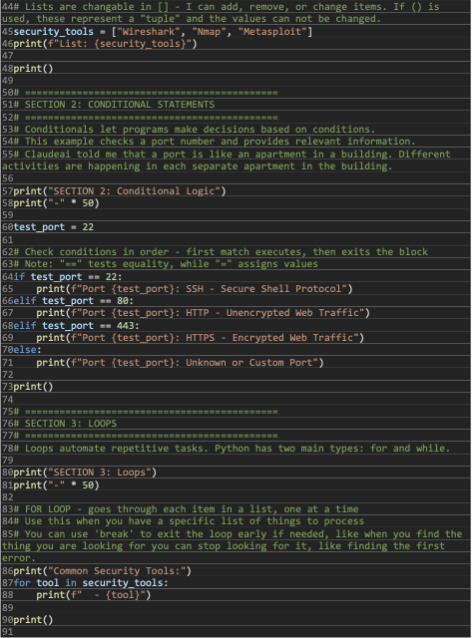

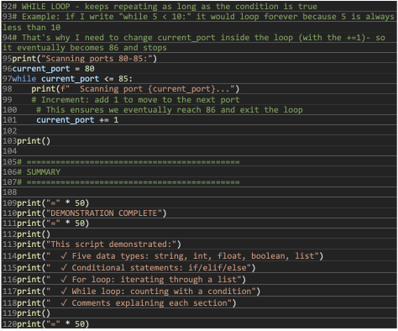

08_python_basics_output.png
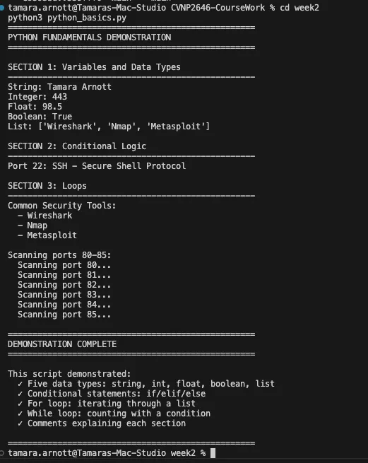
09_python_basics_github.png
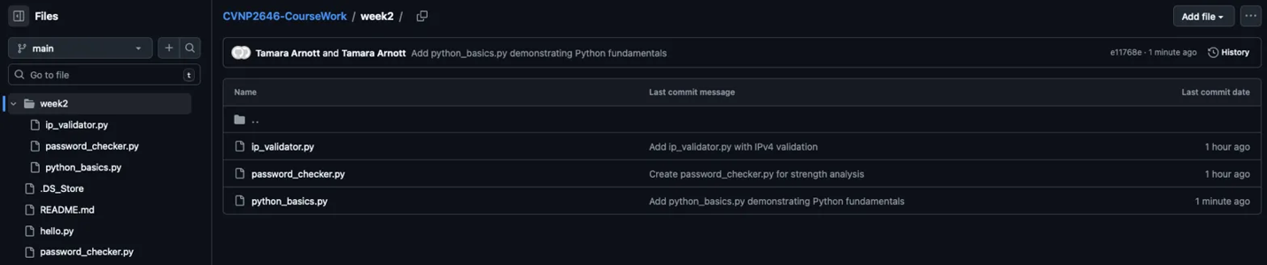

REFLECTION
The week 2 assignments taught me how to check if data is correct (like making sure IP addresses are formatted right), how to let the code repeat tasks automatically instead of doing them over and over, and how to build tools that actually work. This is exactly the type of learning that will help me progress in my Data Analytics & AI certificate program (and can apply to my current work within a higher education setting). Being able to write code that checks data and processes information for me will make the work more efficient in the areas that I supervise. Automating this stuff will help me and my staff to spend more time on serving people and looking at the big picture – keeping us moving forward towards reaching our strategic and annual workplan goals.

